**Resort Management System**

Based on the following tables, write queries to get the results what we are looking for.

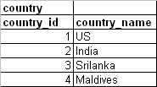

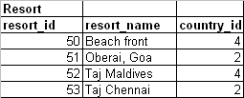

|  |  |  |  |
| --- | --- | --- | --- |
| **customer** |  |  |  |
| **cust_id** | **cust_name** | **phone** | **country_id** |
| 1001 | Tim Downey | 123456789 | 1 |
| 1002 | Ramesh K | 596869689 | 2 |
| 1003 | Bill Price | 74849498 | 1 |
| 1004 | Malinga | 83733938 | 3 |
| 1005 | Farooq | 8958498 | 4 |

1. Query to find out country wise resort count.
2. Query to display country wise customer count.
3. Query to display country, resort count and customer count.
4. Display Resort country name, resort name, customer name and customer country name.
5. Display countries in which we don’t have any resorts.
6. Display countries in which we have minimum of 100 customers.
7. Display how many resorts we have in the country where resort ‘Beach front’ is
8. Display customers whose name starts with F or R and who are either from India or Srilanka.
9. Display customer names who are from US and do not have any phone numbers.
10. Display Country name, resort name. Display all the countries in the list whether we have resorts or not.